WAGNER ELEMENTARY SCHOOL
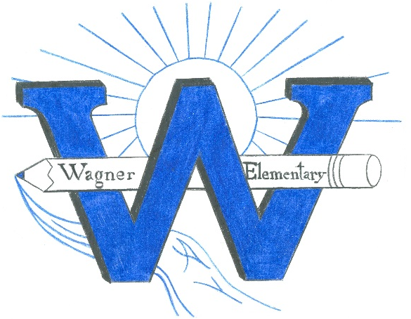
OF The North east School Division #200

Phone: 306-862-5434 Email: wagner@nesd.ca Fax: 306-752-1933
308-9th Ave W, PO Box 460, Nipawin, Saskatchewan S0E 1E0

Principal: Erik Kendrick Vice-Principal: Kathy Chabot

- Call to order: November 23, 2023 5:30
- Adoption of the Agenda
- Minutes
  - October meeting
- Financial report
- SCC Work Plans
- Student led conferences October 25 & 26
  - Numbers
        - of 76 grade 4’s
- of 62 grade 5’s 62
- of 73 grade 6’s
  - Suppers – discussion on how it went.
- Principals report
- Madison Cameron presentation “The Impacts of Social Media”
Wagner January 9th from 9:15-10:15 for students
For parents 7-8:00 at LP Miller
- Fundraising
  - Coop gift cards Nov 27-Dec 4
  - Candy canes December
  - Ideas for fundraising money

- Wizard of OZ
- Report card Feedback
- Bookfair – $3900 in sales which turns into around $1400 for us to spend.
- Christmas Concert December 20th
- Christmas Calendar – done by the Leadership group
- Edsby – Still looking to connect with families online. Notification settings

Future meeting (Stacy will come to one)
January 25 March 21
April 24 May 23 Supper meeting

