WAGNER ELEMENTARY SCHOOL

OF The North east School Division #200

Phone: 306-862-5434 Email: wagner@nesd.ca Fax: 306-752-1933
308-9th Ave W, PO Box 460, Nipawin, Saskatchewan S0E 1E0

Principal: Erik Kendrick Vice-Principal: Kathy Chabot

Present: Erik Kendrick, Carnie Carr, Trevor Salisbury, Shelinda Hill, Amanda Ritthaler, Jessica Griffin, Jan Boughen, Mike Peifer
- Call to order. Mike called the meeting to order at 5:49pm
- Adoption of the Agenda- Jan adopts the agenda
- Minutes – Minutes from September meeting were reviewed prior to the meeting and a motion to approve was made by Trevor.
  - September meeting
- Financial report- Jessica presented the financial report. Currently sitting with $393.62 balance in our account. $98.00 outstanding for SCC pizza supper. Jessica has sent in the financial reports to apply for our grant money. Banking statements will be changing to digital by December 2023. Trevor motions to approve financial report, Amanda seconds.
- Elections / Offices- Carnie nominates Jan for chair person for SCC, Jessica seconds, carried.
Carnie nominates Shelinda for vice chair person for SCC, Jessica seconds, carried.
Jan nominates Amanda for secretary for SCC, Jessica seconds, carried.
Jan nominates Jessica for SCC treasurer, Carnie seconds, carried.
- School Level Action Plans – Erik presented the school level action plans and explained SCC helps to provide direction in them. The main objectives are to set goals for students (focusing on reading and writing skills), enhancing student engagement, and providing a safe place for students to be. Continue working on having more conversations “digitally” through Edsby and getting more regular updates on students work through the learning stories. Focusing on OHS safety (fixing concrete/sidewalks, improving safety) Mike motions to approve the school level action plans, Jessica seconds, carried.
- SCC Work Plans
  - Fundraising support – Mike has started to reach out for sponsorship from the agriculture side (chemical reps) but needs a letter from the school as to where funds will be spent. Proposed projects for fundraising amounts are playground equipment, basketball court, cross country skis, boots, and snow shoes. Erik is going to do an inventory on current skis/boots and see what is available and what is needed. Talked about gathering donations to do a silent auction at a Christmas function to raise money.
- Student led conferences October 25 & 26- worked with the other schools to spread out Student led conferences so parents are able to attend all conferences when they have children in multiple schools. The SCC is currently organizing a potluck supper to provide for the teachers both nights.

- Remembrance Day Service Nov 10 @ 11- Mr. Umpherville and Mrs. Steven’s classes are currently planning the Remembrance Day service. Parents and members of the public welcome to attend.
- Principals report
  - Sales
- Freezie Sale
- Donut Sale 47 sponsored – lots of extra donuts sponsored. Put that extra money aside for future events.
- Clothing Sale
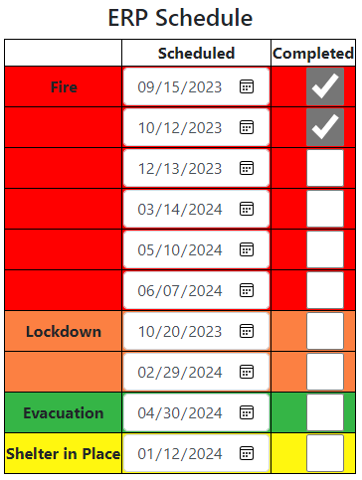
- Coop gift cards Nov 27-Dec 4
- Candy canes Dec
  - Ideas for fundraising money
- High jump mats
- Awards & prizes
- Bookshelves for teachers
- Gym Blast- working to see if we can co-ordinate a gym blast conjunction with L.P. Miller to help save costs. It is a program that gets kids up, moving and motivated.
  - ERP – been holding fire drills- tomorrow will be a lockdown drill
  - Education week- many events going on- Stem challenge- building a balloon tower, pancake breakfast, pizza lunch, reading to kids at CPES, bright coloured shirt day on Friday.
  - Intramural’s- lots of intramurals and clubs happening around the school- dodgeball, flag football, drama, art club, Earth’s angels recycling club

- Staffing
  - New EA- going to be hiring a new EA on a temporary contract.
- Bookfair – Support from SCC?- looking for help from SCC. Jan will come in Friday to help set up for the bookfair. Jessica will look into a schedule of volunteers to help run the book fair in the evening. Advertise that we will be accepting debit/credit cards as that might entice more parents to buy.
- Edsby – Staff are working with students to get them more comfortable with posting and navigating through Edsby. Students were excited to see that they could look back on their past learning stories and see their posts. Hopeful that the more comfortable the students are with Edsby, they will tell their parents and get them checking more regularly. Carnie is creating a SCC group on Edsby to communicate better with members.
- Future meetings
Next meeting is Thursday November 23, 2023 at 5:00pm.
Jessica motions to adjourn the meeting at 6:47pm.

